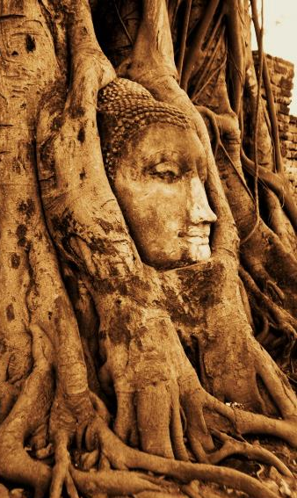
On an Ancient Wall in China,
Where a brooding Buddha blinks
Deeply graven is the message
it is later then you think.
The clock of life is wound but once
And no one has the power,
To know just when the hands will stop
At late or early hour.
Now is all the time you have
The Past a Golden Link
Go now my Brother, it is later then you think.

Anonymous

